16CA4006

Q 1(a) [5 Marks]

The code below constructs an image of a disc of radius 15

load dist;

disc = dist < 15;

Compute the Fourier Transform of the image and display the Fourier Transform (not the log of the Fourier Transform!) on your screen. Remember to scale the brightness of the FT. Sketch the FT in your exam booklet.

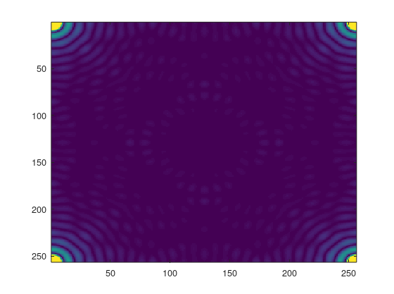

disc = dist < 15;

y = fft2(disc);

image(256\*abs(y)/max(max(abs(y))))

Q 1(b) [5 Marks] The code below constructs a mask such as the one below, known as a circular bandpass filter, where r1 is the inner radius and r2 is the outer radius. The centre of the circles is the point (1,1).

load dist;

mask = dist > r1 & dist < r2;

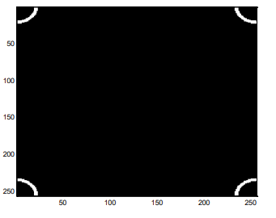

You can construct a mask consisting of multiple band-pass filters like this.

mask = (dist > r1 & dist < r2) + (dist > r3 & dist < r4) ...;

Construct such a mask which will let through the Fourier Transform of the disc image from part 1(a). Write the Matlab commands in your exam booklet. Save the mask on your computer. Which radii did you choose and why?

mask = (dist > 0 & dist < 15) + (dist > 18 & dist < 24) + (dist > 28 & dist < 34) + (dist > 36 & dist < 42) + (dist > 44 & dist < 50);

y2=y.\*mask;

image(256\*abs(y2)/max(max(abs(y2))))

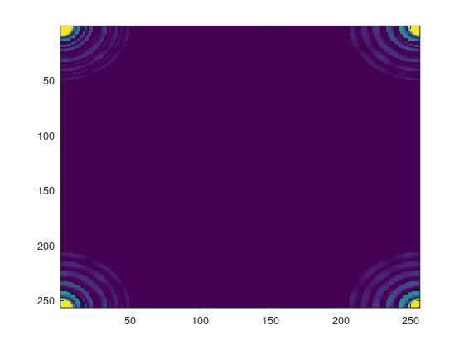

Q 1(c) [5 Marks]

Load the image london, which contains a satellite image of part of London with the Millennium Dome in the centre of the image. Multiply the Fourier Transform of london by your multiple band-pass filter and Inverse Transform it. Save the filtered image on your computer. Write the Matlab commands in your exam booklet. What effect has your filter had on the image – and on the Millennium Dome in particular? Explain why.

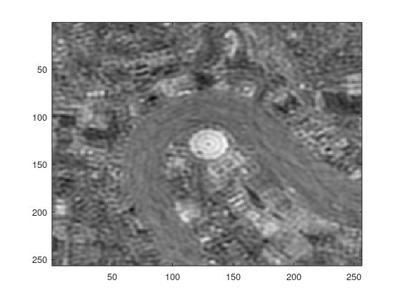

y=fft2(london);

y2 =y.\*mask;

z=ifft2(y2);

image(256\*abs(z)/max(max(abs(z))))

The filtered image. You can see that most of the image has been reduced apart from the Millennium Dome, which has a radius of 15 pixels and whose FT is therefore let through by the mask

Q 1(d) [5 Marks]

Compute the Impulse Response corresponding to this mask. Display the real part of the Impulse Response using surf. Sketch it in your exam booklet. Plot the first row of the real part of the Impulse Response. Sketch it in your exam booklet.

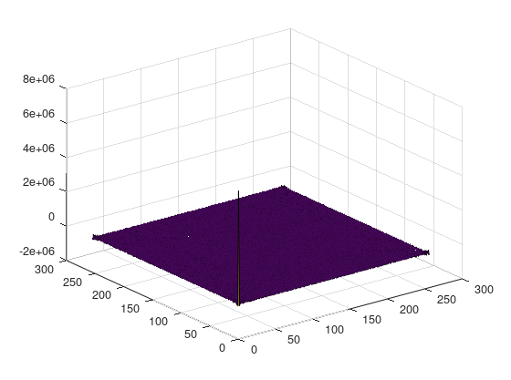

surf(real(y))

plot(real(y(1,:)))

Q 1(e) [5 Marks]

Explain how convolving the london image with this Impulse Response leads to the effect in part (d).

Objects smaller than the Dome will be smoothed out by the central peak. Circular objects with a radius of 15 will be preserved by the sigmoid structure around pixel 30. This counteracts the effect of the central peak – but only for objects with radius 15.

Q 2(a) [5 Marks]

Load the image objects, which consists of a number of rectangular objects lying horizontally and vertically. Fourier Transform the image and display the Fourier Transform on your screen. You can use the default colormap. Remember to scale the brightness of the FT. Sketch the FT in your exam booklet. Explain the structure of the FT.

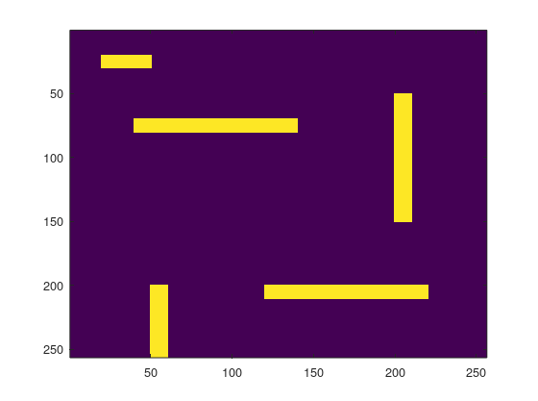

image(256\*objects);

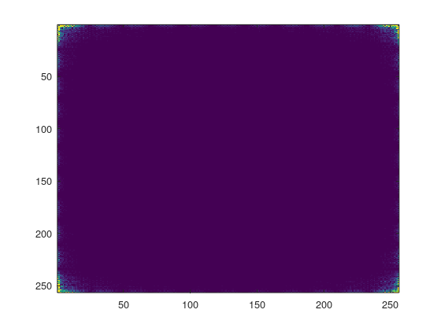

y=fft2(objects);

image(256\*abs(y)/max(max(abs(y))))

The FT of the objects image. The FT of the vertical objects lies along the horizontal sides of the figure. The FT of the horizontal objects lies along the vertical sides. There are dark bands in the FTs whose spacing is inversely proportional to the widths of the objects.

Q 2(b) [5 Marks]

Create a binary mask, in which the first n columns and the last n columns are all set to 1 (with n=10) and everything else is 0. Write the Matlab commands in your exam booklet. Multiply the FT by your mask and Inverse Transform it. Sketch the filtered image in your exam booklet. Write the Matlab commands in your exam booklet.

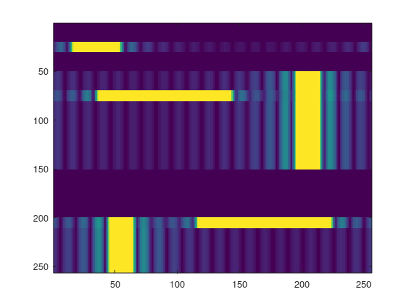

mask = zeros(256,256);

mask(:,1:10)=1;

mask(:,246:256)=1;

x=y.\*mask;

z=ifft2(x);

image(256\*abs(z)/max(max(abs(z))))

This is the filtered image with a mask of width 10. Vertical objects have been degraded compared to the horizontal objects.

Q 2(c) [5 Marks]

Explain the structure of the filtered image. What effect does varying n have on the filtered image? Explain why.

The mask will let through most of the FTs of horizontal objects but it will also let through a small part of the FTs of vertical objects. If we make the mask narrower we will exclude even more of the vertical objects but we will also reduce some of the shorter horizontal objects because their FTs will be wider.

Q 2(d) [5 Marks]

Now modify the mask in part (b) by setting the first m rows and the last m rows to 0 (with m=10). Write the Matlab commands in your exam booklet. Multiply the FT by your mask and inverse transform it. Sketch the filtered image in your exam booklet. Write the Matlab commands in your exam booklet.

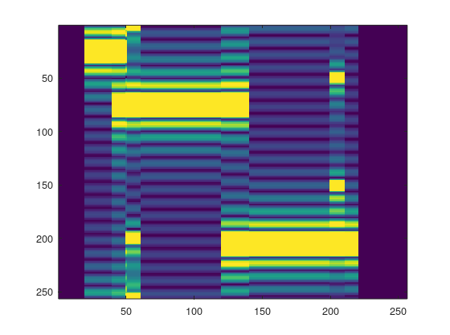

mask = ones(256,256);

mask(246:256,:)=0;

mask(1:10,:)=0;

x=y.\*mask;

z=ifft2(x);

image(256\*abs(z)/max(max(abs(z))))

Q 2(e) [5 Marks]

Explain the structure of the filtered image. What effect does varying m have on the filtered image? Explain why

By setting the first and last m rows to 0 we remove some of the low frequency horizontal information leaving only horizontal edges. If we increase m we will remove more low frequencies and the edges will get thinner

Q 3(a) [10 Marks]

Using Matlab load the file checkerboard The image contains an 8x8 checkerboard in the top left corner. Compute the Fourier Transform of this image and display it (not the log of the FT!) on the screen. It is probably better to use the default colormap. Remember to scale the brightness of the Fourier Transform. Sketch it in your exam booklet.

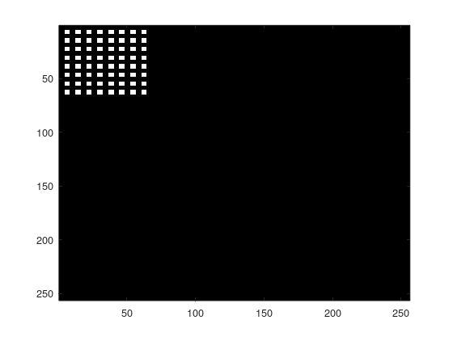

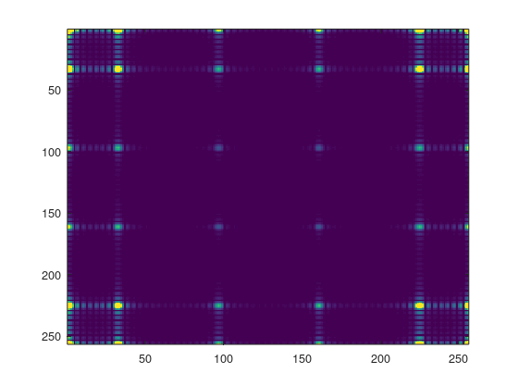

y=fft2(checker);

image(256\*abs(y)/max(max(abs(y))))

Q 3(b) [15 Marks] Using the Convolution Theorem explain the following three features of the Fourier Transform

1. The FT contains replication. Which component of the FT is being replicated? Which aspect of the image gives rise to this component?
2. Which aspect of the image causes the replication? What determines the spacing of the replications?
3. Why are some of the replications less bright than others or even missing altogether?
4. The replicated component is the coss-shaped structure which is centred on (1,1) and extends out to 16 along both axes. It represents the FT of a 64x64 white square which is the putative filled in checkerboard
5. The replication is caused by the sampling of the white square by a grid with spacing 8 pixels in each direction. The spacing of the replications is inversely proportional to the spacing of the grid.
6. Some of the replications are reduced or missing because the FT is multiplied by the FT of the small 4x4 squares which make up the checkerboard. This FT will have zeros at intervals of 64 along both axes.

16CA4006

Q 1(a) [5 Marks] Load the images smalldisc and disc, which contain images of discs. The disc in disc has twice the radius of the disc in smalldisc. Fourier Transform the images and display the Fourier Transforms (FTs) on your screen. Remember to scale them. Sketch the FTs in your exam booklet. Explain the differences between the two FTs.

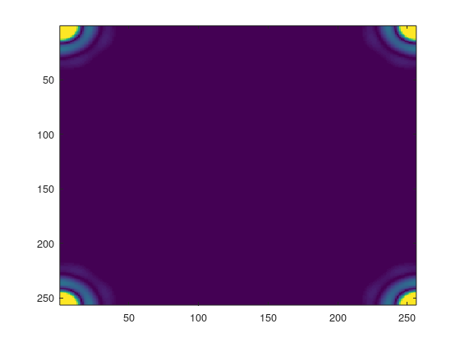

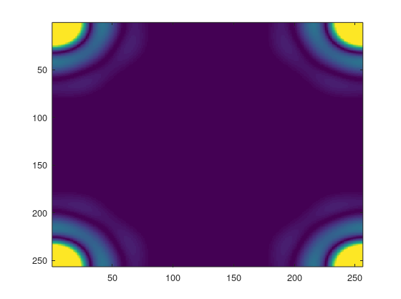

The Fourier Transform of smalldisc. This is more spread out than the FT of disc. This illustrates the reciprocal nature of FTs i.e. the larger the object the smaller its FT and vice versa.

Q 1(b) [5 Marks]

Now create an image x which is the sum of disc and smalldisc. Compute the FT of x.

x = disc + smalldisc

The code below constructs a mask such as the one below, known as a circular bandpass filter, where r1 is the inner radius and r2 is the outer radius. The centre of the circles is the point (1,1).

load dist;

mask = dist > r1 & dist < r2;

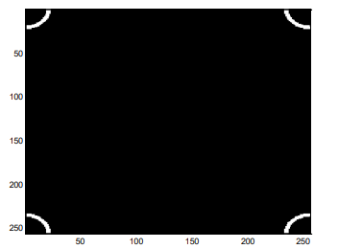

Construct a band-pass filter which lets through a part of the FT of x which contains mainly data due to smalldisc. Which radii did you choose and why?

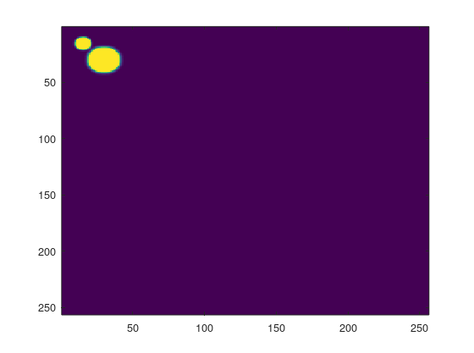

x = disc + smalldisc;

mask = dist > 38 & dist < 48;

Filtered image with r1 = 38, r2 = 48

These radii select the bright blue band in the FT of smalldisc. Here the data from smalldisc predominates over the data from disc. The filtered image above has removed disc and only smalldisc remains.

Q 1(c) [5 Marks] Multiply the FT of x by the band-pass filter and Inverse Transform it. Sketch the filtered image in your exam booklet. Write the Matlab commands in your exam booklet. Explain the structure of the filtered image

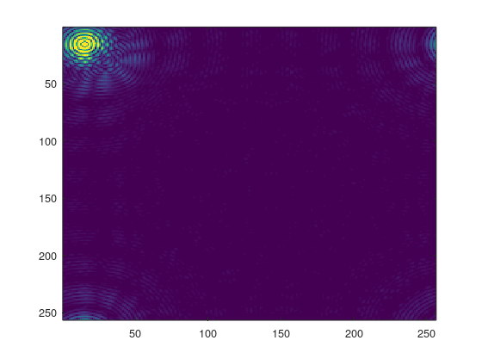

y = fft2(x);

z=y.\*mask;

y2 = ifft2(z);

image(256\*abs(y2)/max(max(abs(y2))))

Q 1(d) [5 Marks] Construct a band-pass filter which lets through a part of the FT of x which contains mainly data due to disc. Which radii did you choose and why? Multiply the FT of x by the band-pass filter and Inverse Transform it. Sketch the filtered image in your exam booklet. Write the Matlab commands in your exam booklet. Explain the structure of the filtered image.

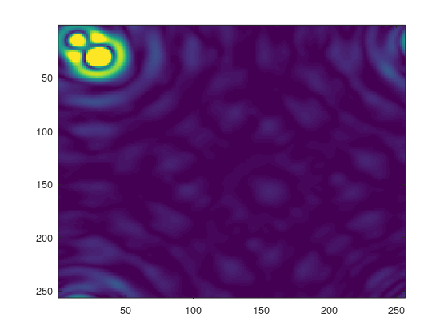

mask = dist > 5 & dist < 15;

y = fft2(x);

z=y.\*mask;

y2 = ifft2(z);

image(256\*abs(y2)/max(max(abs(y2))))

Filtered image with r1 = 5, r2 =15

These radii select part of the central lobe of the FT of disc. Because the FT of disc is more concentrated than that of small disc, the data from disc predominates in this region. The filtered image has enhanced disc although some data from smalldisc still survives.

Q 1(e) [5 Marks] What effect does the binary nature of the mask have on the filtered images? Describe how you would reduce this effect.

The binary nature of the mask leads to the ghost images or rings in the above filtered images. These could be reduced by convolving the binary mask with a Gaussian with standard deviation about 2 or 3. Alternatively a difference of Gaussians filter could be used.

Q 2(a) [5 Marks]

Load the image objects, which consists of a number of rectangular objects lying horizontally and vertically. Fourier Transform the image and display the Fourier Transform on your screen. You can use the default colormap. Remember to scale the brightness of the FT. Sketch the FT in your exam booklet. Explain the structure of the FT.



y=fft2(objects);

image(256\*abs(y)/max(max(abs(y))))

The FT of the objects image. The FT of the vertical objects lies along the horizontal sides of the figure. The FT of the horizontal objects lies along the vertical sides. There are dark bands in the FTs whose spacing is inversely proportional to the widths of the objects

Q 2(b) [5 Marks] Create a binary mask which will let through horizontal objects but impede vertical ones. Sketch the mask in your exam booklet. Explain the structure of your mask. Write the Matlab commands in your exam booklet.

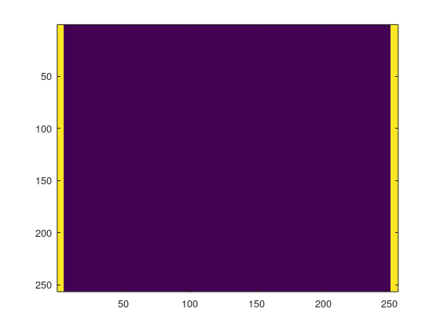

mask = ones(256,256);

mask = zeros(256,256);

mask(:,1:5)=1;

mask(:,251:256)=1;

image(256\*mask)

This shows the mask which will reduce vertical objects and enhance horizontal ones. Due to the reciprocal nature of FTs, the FTs of horizontal objects will lie along the vertical edges and the FTs of vertical objects will lie along the horizontal edges. The above mask will let through most of the FTs of horizontal objects but it will also let through a small part of the FTs of vertical objects. If we make the mask narrower we will exclude even more of the vertical objects but we will also reduce some of the shorter horizontal objects because their FTs will be wider.

Q 2(c) [5 Marks] Multiply the FT by your mask and inverse transform it. Sketch the filtered image in your exam booklet. Write the Matlab commands in your exam booklet. Explain the structure of the filtered image.

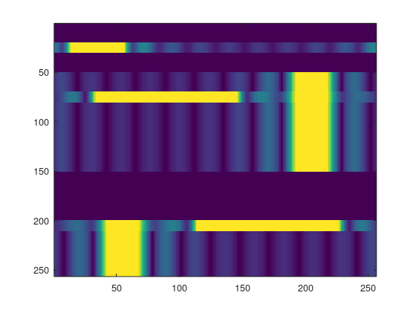

x = y.\*mask;

z =ifft2(x);

image(256\*abs(z)/max(max(abs(z))));

This is the filtered image with a mask of width 5. Vertical objects have been degraded compared to the horizontal objects.

Q 2(d) [5 Marks] Compute the Impulse Response function corresponding to the mask. Describe the structure of the Impulse Response. Sketch it in your exam booklet.

Surf(real(y))

plot(real(y(1,:)))

Q 2(e) [5 Marks] Explain using diagrams how convolving the objects image with this Impulse Response reduces vertical objects more than horizontal ones. What effect does the Impulse Response have on the ends of the horizontal objects? Explain why

When the above Impulse Response is convolved with a horizontal object of length >> 50 it will have little effect on the object except at the ends where contributions from the background will start to reduce the values of the filtered image. For vertical objects of width < 50 the whole object will be swamped with contributions from the background and the objects will be degraded.

Q 3(a) [5 Marks]

Using Matlab load the file abdiag

The image contains the letters A and B superimposed on each other. Both letters have been sampled diagonally but the sample direction of A is perpendicular to that of B.

Compute the Fourier Transform of this image and display it on the screen. It is probably better to use the default colormap. Remember to scale the brightness of the Fourier Transform. Sketch it in your exam booklet.

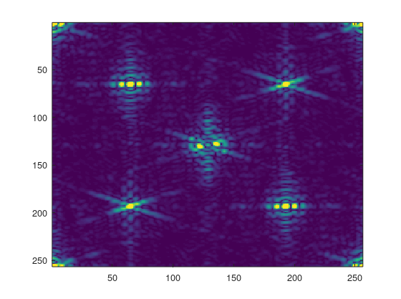

y=fft2(abdiag);

image(256\*abs(y)/max(max(abs(y))));

Q 3(b) [5 Marks]

Using the Convolution Theorem explain the structure of the Fourier Transform.

Because the image is sampled the FT is replicated. The A image is diagonally sampled top-right to bottom-left so its FT is replicated in that direction. The B image is sampled top-left to bottom-right so its FT is replicated in that direction.

Q 3(c) [5 Marks] In Matlab construct a mask that will let through only the letter B. Sketch the mask in your exam booklet. Multiply the Fourier Transform by your mask. Carry out an Inverse Transform and sketch the filtered image in your exam booklet. Write the commands in your exam booklet.

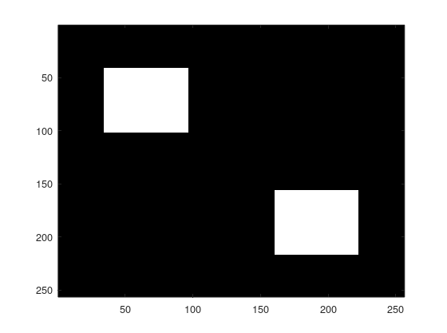

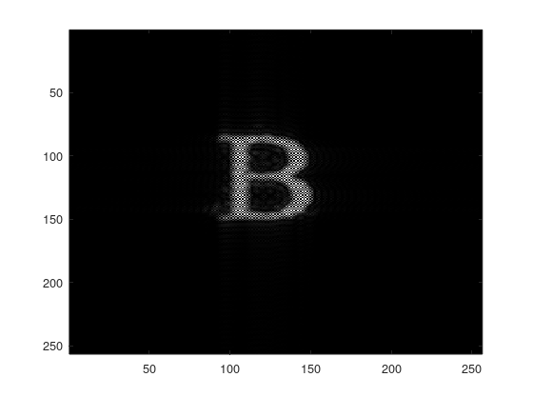

mask=zeros(256,256);

mask=createMask3(mask,y,1);

z=y.\*mask;

y2=ifft2(z);

image(256\*abs(y2)/max(max(abs(y2))));

Q 3(d) [5 Marks] Compute the Impulse Response Function corresponding to this mask. Sketch it in your exam booklet. You should display the real and imaginary parts separately. You can use the Matlab function bar3.

Q 3(e) [5 Marks] Explain using pictures, if necessary, how convolving the image in part (a) with the Impulse Response Function in part (d) leads to the image in part (c).

The central pixel of the impulse response is (1,1). From the top figure you can see that three pixels at (3,2),(2,2) and (2,3) are all large, negative and real. From the second figure you can see that the pixels at (1,2) and (2,1) are large and negative and imaginary. These five pixels fill in the gaps between the diagonal samples of the B.

The fact that the pixel at (2,2) is real and negative means it will cancel out the diagonals of the A. The central positive pixel at (1,1) and pixel (2,2) lie along the diagonals of the A. So at each point the contribution from the central pixel and its negative neighbours will sum to zero.

20CA4006

QUESTION 1 [TOTAL MARKS: 25] Please put all your answers for this question into a Word doc called Q1.doc

Load the image diags, which represents two groups of pins scattered randomly over a plane. Display the image on your screen.

Load the file maskdiags, which contains a mask which is designed to let through the parts of the Fourier Transform (FT) corresponding to one group of pins.

For your information you can display maskdiags on your screen. You can compare it to the FT of diags.

Q 1(a) [5 Marks]

Multiply the FT of diags by maskdiags and Inverse Transform it. Display the filtered image using the gray(256) colormap and copy it into Q1.doc. Copy the Matlab commands into Q1.doc. Describe the structure of the filtered image. How does it differ from the original diags image? Explain the effect on each of the two groups of pins.

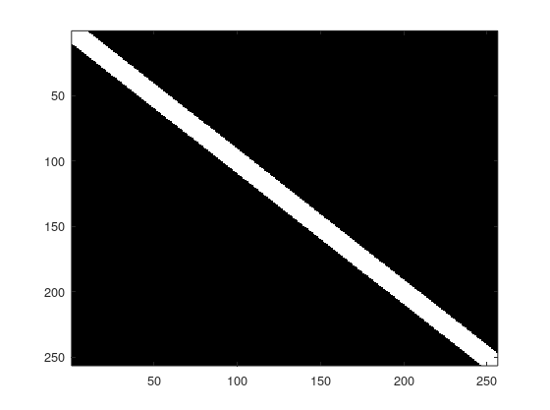

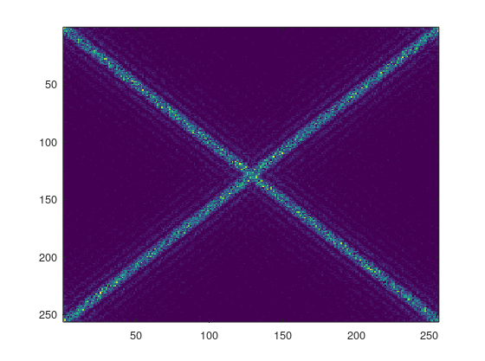

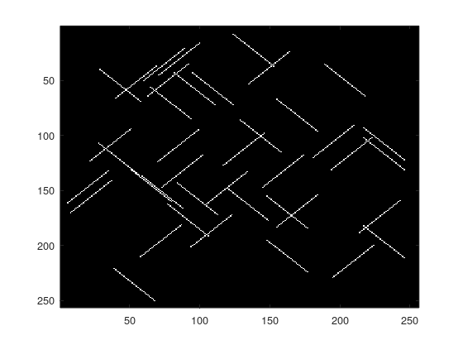

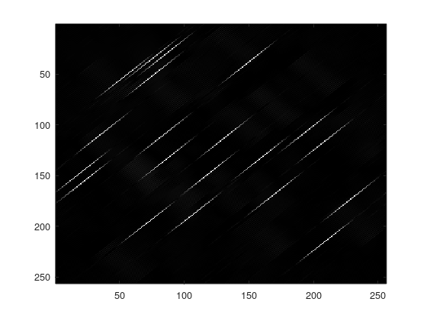

image(diags)

image(256\*maskdiags)

y=fft2(diags);

image(256\*abs(y)/max(max(abs(y))))

x=y.\*maskdiags;

z=ifft2(x);

image(256\*abs(z)/max(max(abs(z))))

The filtered image shows that one group of pins has been reduced, although some highly blurred pins remain. Due to the shifting and scaling properties of FTs, the FTs of all the pins in this group fall in the diagonal band running from bottom-left to top-right in the FT shown on the previous page. This group was blocked by maskdiags The remaining pins have their ends slightly blurred because the high frequencies of this group were also blocked by maskdiags.

Q 1(b) [5 Marks]

Compute the Impulse Response corresponding to maskdiags. The Impulse Response is the FT of maskdiags Copy the Matlab commands into Q1.doc. Display the real part of the Impulse Response using surf. You may wish to look at it from different viewpoints to get the full structure. Copy your different views into Q1.doc

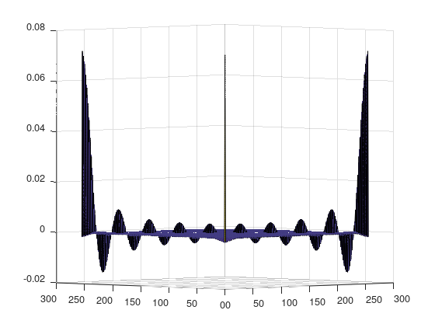

surf(real(y2))

Q 1(c) [5 Marks] Explain why convolving the diags image with this Impulse Response would have the effects shown in part (a). Explain the effect on each of the two groups of pins

From the above two images we can see that the impulse responses lies along the direction of the surviving group of pins. When this is convolved with pins from that group, each pixel within each pin will receive a positive contribution from its neighbours within that pin. However, towards the ends of the pin the contributions will be less since there will be fewer neighbours on the outer side of the pixel. This explains the blurring at the ends. The pixels in pins in the other group will receive no contribution from their neighbours, since the impulse response is perpendicular to the pins that group. So the convolved pins will be much less bright then the pins in the remaining group.

Q 1(d) [5 Marks] If the pins were twice as long, what effect would it have on the FT of diags?

The two diagonal bands in the FT (as seen on page 2) would be squeezed and would appear thinner. This is due to the Principle of Shifting and Scaling. The thickness of the diagonal bands is inversely proportional to the length of the pins.

If you were to multiply this new FT by maskdiags and Inverse Transform it, how would the effect on the pins differ from the effect in part (a)? Explain your answer.

The hole in the mask would stay the same width but the diagonal bands would be squeezed. Therefore, more of the FT of the pins would get through the mask. So the blurring would be less relative to the length of the pins.

Q 1(e) [5 Marks]

If you the pins were twice as long, what would be the effect of convolving them with the Impulse Response from part (b)? Explain your answer.

Because the mask is the same, the Impulse Response would be the same. Therefore, the blurred portion at the end of each pin would be the same size. However, because the pins would be longer, the blurred portion would be a smaller percentage of the length of the pin. There may also be some dips in brightness in the centre of the pins due to the negative portions of the Impulse Response.

Q 2(a) [4 Marks]

Load the image woodsman, which contains an image of a man in a jacket carrying an axe. Display the image on your screen. Fourier Transform (FT) the image and display the log of the FT on your screen using the gray(256) colormap. Copy the FT into Q2.doc

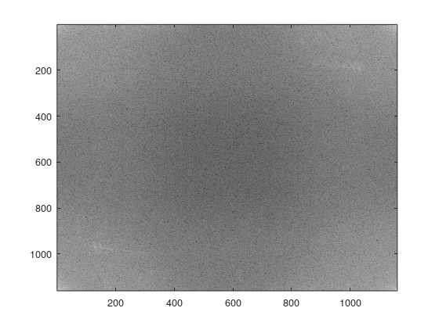

y=fft2(woodsman);

image(256\*log(abs(y))/max(max(log(abs(y)))))

colormap(gray(256))

Q 2(b) [21 Marks] For each of the following parts of the image, identify which structures in the FT correspond to that part:

1. The fingers [7 marks]

2. The part of the jacket in the bottom left corner of the image (below row 800 and left of column 300) [7 marks]

3. The trousers [7 marks]

In Q2.doc indicate using arrows or boxes on the FT which structures correspond to which of the above parts of the image. Construct masks to filter out each structure in the FT. Display the mask on your screen and copy it into Q2.doc In Matlab multiply the FT by the masks and Inverse Transform them. Display the filtered images and copy them into Q2.doc Explain why those structures lie in those particular locations in the FT. In your explanations you may use one or more of the following principles (if you think they are relevant) shifting and scaling, sampling and replication, and the convolution theorem. Some of the parts of the image may contain wave-like patterns. If you think this is the case, you could estimate the frequencies of these waves and use them to explain the location of the corresponding structures in the FT.

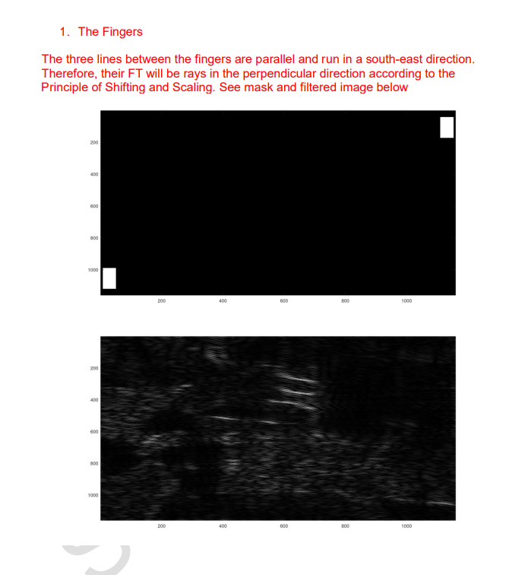

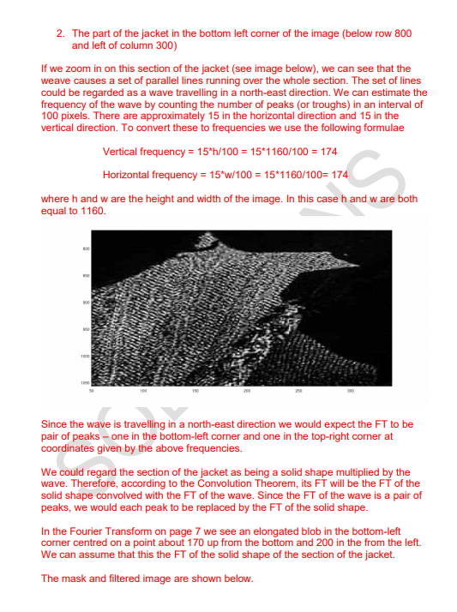

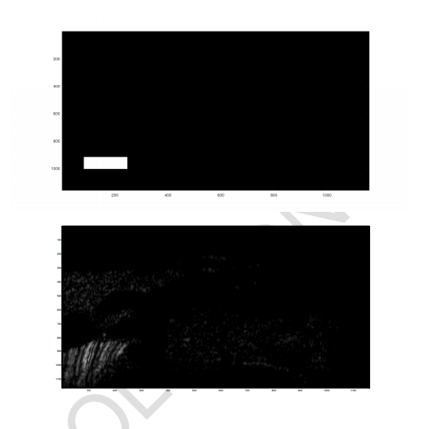

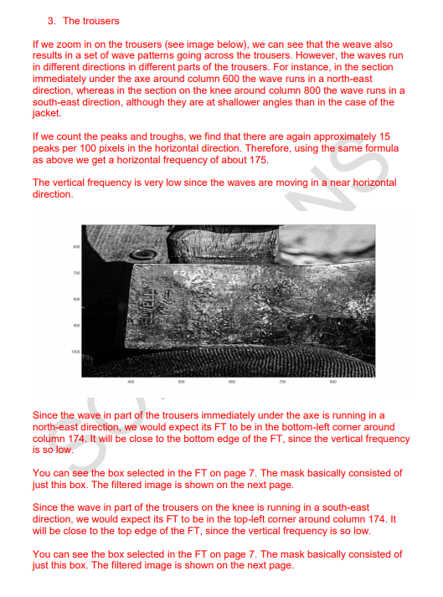

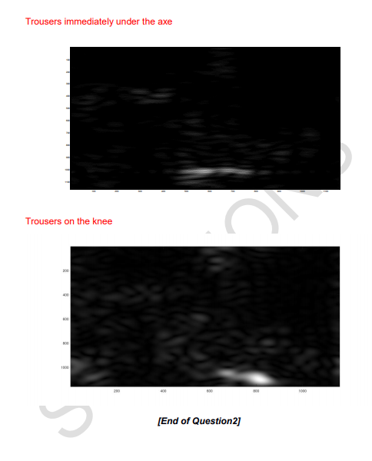

Q 3(a) [5 Marks]

Load the image chevrons into Matlab, which contains a pattern of chevrons in the top left corner. Display the image on your screen. This pattern contains sampling in different directions. What shapes are being sampled in each direction?

The chevrons image can be regarded as two pairs of triangles. The first pair have their bases parallel to the top and bottom edges. This pair are sampled horizontally with a spacing of 6 pixels. The other pair have their bases parallel to the left and right hand sides. This pair are sampled vertically also with a spacing of 6 pixels.

(If you want to check the spacing, it is easiest to do this by doing a stem plot through the first row or column).

Q 3(b) [2 Marks]

Fourier Transform (FT) the image and display the FT (not the log of the FT) using the default colormap on your screen. Copy it into Q3.doc.

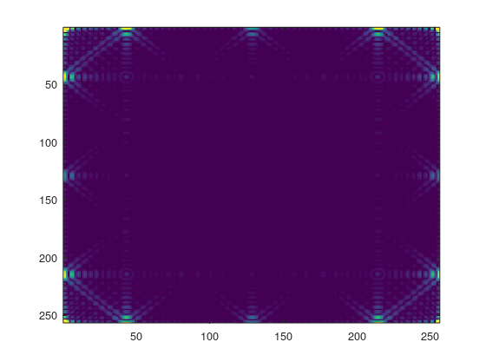

y=fft2(chevrons);

image(256\*abs(y)/max(max(abs(y))))

Q 3(c) [8 Marks]

Explain the structure of the FT using the Principle of Sampling and Replication. You should refer to your answer to part (a) above. You should fully explain which structures in the FT are caused by the sampling in the chevrons image. Create masks and filtered images to support your answer. Display them on your screen and copy them into Q3.doc

The Convolution Theorem leads to the Principle of Sampling and Replication, which states that if an object in an image is sampled then its Fourier Transform will be replicated. The spacing of the replications is inversely proportional to the sample spacing.

The first pair of triangles is sampled horizontally with a spacing of 6. Therefore, their FT will be replicated horizontally with a spacing of

256/6 = 42.66

where 256 is the width of the image. So the replications which lie along the top and bottom edges of the FT represent the first pair of triangles. However, you will notice that some replications are “missing”. We would expect to see replications at columns 85 and 171 but they are not visible. The reason for this is discussed in part (e) below.

For similar reasons, the replications which lie along the left and right hand sides of the FT represent the other pair of triangles.

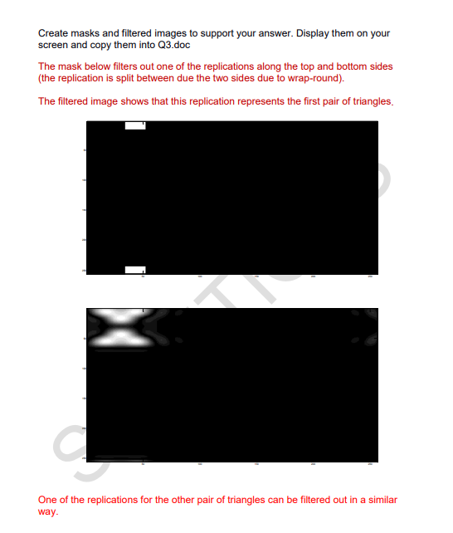

Q 3(d) [4 Marks] The chevrons pattern can be regarded as a convolution, in which the impulse response is a 3x3 square. Deconvolve the chevrons pattern using this impulse response and display the deconvolved image in your screen. Copy your Matlab commands into Q3.doc. And copy the deconvolved image into Q3.doc.

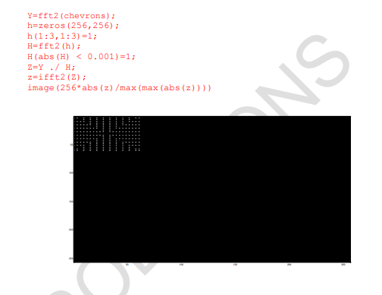

Q 3(e) [6 Marks] Explain how convolving this image with a 3x3 square leads to the chevrons pattern

